# Описание базы данных

## Диаграммы

### ER

ХЭШ ТАБЛИЦА

#* Дата

* Хэш сумма

ФАЙЛЫ

#* Код

* Путь

ОШИБКИ

#* Дата

* Описание

### DLM

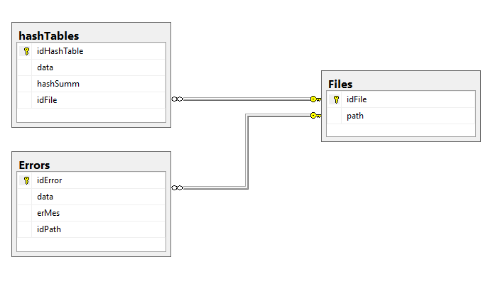

## Скрипты

### Создание БД

CREATE DATABASE [HashTableDb]

CONTAINMENT = NONE

ON PRIMARY

( NAME = N'HashTableDb', FILENAME = N'D:\Program Files\Microsoft SQL Server\MSSQL11.SRVWS30\MSSQL\DATA\HashTableDb.mdf' , SIZE = 5120KB , FILEGROWTH = 1024KB )

LOG ON

( NAME = N'HashTableDb_log', FILENAME = N'D:\Program Files\Microsoft SQL Server\MSSQL11.SRVWS30\MSSQL\DATA\HashTableDb_log.ldf' , SIZE = 2048KB , FILEGROWTH = 10%)

GO

ALTER DATABASE [HashTableDb] SET COMPATIBILITY_LEVEL = 110

GO

ALTER DATABASE [HashTableDb] SET ANSI_NULL_DEFAULT OFF

GO

ALTER DATABASE [HashTableDb] SET ANSI_NULLS OFF

GO

ALTER DATABASE [HashTableDb] SET ANSI_PADDING OFF

GO

ALTER DATABASE [HashTableDb] SET ANSI_WARNINGS OFF

GO

ALTER DATABASE [HashTableDb] SET ARITHABORT OFF

GO

ALTER DATABASE [HashTableDb] SET AUTO_CLOSE OFF

GO

ALTER DATABASE [HashTableDb] SET AUTO_CREATE_STATISTICS ON

GO

ALTER DATABASE [HashTableDb] SET AUTO_SHRINK OFF

GO

ALTER DATABASE [HashTableDb] SET AUTO_UPDATE_STATISTICS ON

GO

ALTER DATABASE [HashTableDb] SET CURSOR_CLOSE_ON_COMMIT OFF

GO

ALTER DATABASE [HashTableDb] SET CURSOR_DEFAULT GLOBAL

GO

ALTER DATABASE [HashTableDb] SET CONCAT_NULL_YIELDS_NULL OFF

GO

ALTER DATABASE [HashTableDb] SET NUMERIC_ROUNDABORT OFF

GO

ALTER DATABASE [HashTableDb] SET QUOTED_IDENTIFIER OFF

GO

ALTER DATABASE [HashTableDb] SET RECURSIVE_TRIGGERS OFF

GO

ALTER DATABASE [HashTableDb] SET DISABLE_BROKER

GO

ALTER DATABASE [HashTableDb] SET AUTO_UPDATE_STATISTICS_ASYNC OFF

GO

ALTER DATABASE [HashTableDb] SET DATE_CORRELATION_OPTIMIZATION OFF

GO

ALTER DATABASE [HashTableDb] SET PARAMETERIZATION SIMPLE

GO

ALTER DATABASE [HashTableDb] SET READ_COMMITTED_SNAPSHOT OFF

GO

ALTER DATABASE [HashTableDb] SET READ_WRITE

GO

ALTER DATABASE [HashTableDb] SET RECOVERY FULL

GO

ALTER DATABASE [HashTableDb] SET MULTI_USER

GO

ALTER DATABASE [HashTableDb] SET PAGE_VERIFY CHECKSUM

GO

ALTER DATABASE [HashTableDb] SET TARGET_RECOVERY_TIME = 0 SECONDS

GO

USE [HashTableDb]

GO

IF NOT EXISTS (SELECT name FROM sys.filegroups WHERE is_default=1 AND name = N'PRIMARY') ALTER DATABASE [HashTableDb] MODIFY FILEGROUP [PRIMARY] DEFAULT

GO

### Создание таблиц

USE [HashTableDb]

CREATE TABLE [dbo].[files](

[idFile] [int] IDENTITY(1,1) NOT NULL,

[path] [nvarchar](512) NOT NULL,

CONSTRAINT [PK_Files] PRIMARY KEY CLUSTERED

(

[idFile] ASC

)WITH (PAD_INDEX = OFF, STATISTICS_NORECOMPUTE = OFF, IGNORE_DUP_KEY = OFF, ALLOW_ROW_LOCKS = ON, ALLOW_PAGE_LOCKS = ON) ON [PRIMARY]

) ON [PRIMARY]

GO

CREATE TABLE [dbo].[hashTables](

[idHashTable] [int] IDENTITY(1,1) NOT NULL,

[data] AS (getdate()),

[hashSumm] [char](32) NOT NULL,

[idFile] [int] NOT NULL,

CONSTRAINT [PK_hashTables] PRIMARY KEY CLUSTERED

(

[idHashTable] ASC

)WITH (PAD_INDEX = OFF, STATISTICS_NORECOMPUTE = OFF, IGNORE_DUP_KEY = OFF, ALLOW_ROW_LOCKS = ON, ALLOW_PAGE_LOCKS = ON) ON [PRIMARY]

) ON [PRIMARY]

GO

SET ANSI_PADDING OFF

GO

ALTER TABLE [dbo].[hashTables] WITH CHECK ADD CONSTRAINT [FK_hashTables_Files] FOREIGN KEY([idFile])

REFERENCES [dbo].[files] ([idFile])

GO

ALTER TABLE [dbo].[hashTables] CHECK CONSTRAINT [FK_hashTables_Files]

GO

CREATE TABLE [dbo].[errors](

[idError] [int] IDENTITY(1,1) NOT NULL,

[data] AS (getdate()),

[erMes] [nvarchar](1024) NOT NULL,

[idPath] [int] NULL,

CONSTRAINT [PK_Errors] PRIMARY KEY CLUSTERED

(

[idError] ASC

)WITH (PAD_INDEX = OFF, STATISTICS_NORECOMPUTE = OFF, IGNORE_DUP_KEY = OFF, ALLOW_ROW_LOCKS = ON, ALLOW_PAGE_LOCKS = ON) ON [PRIMARY]

) ON [PRIMARY]

GO

ALTER TABLE [dbo].[errors] WITH CHECK ADD CONSTRAINT [FK_Errors_Files] FOREIGN KEY([idPath])

REFERENCES [dbo].[files] ([idFile])

GO

ALTER TABLE [dbo].[errors] CHECK CONSTRAINT [FK_Errors_Files]

### Хранимые процедуры

create proc dbo.saveHash

(@hashSumm char(32), @path nvarchar(512))

as

begin

declare @idFile int

set @idFile=-1

select @idFile=f.idFile from dbo.files f

where f.path=@path

if @idFile=-1 begin

insert into dbo.files(path)

values(@path)

set @idFile=SCOPE_IDENTITY();

end

insert into dbo.hashTables(hashSumm,idFile)

values (@hashSumm,@idFile)

return @idFile

end

go

create proc dbo.saveError(@erMes char(1024), @path nvarchar(512))

as

begin

if @path is not null

begin

declare @idFile int

set @idFile=-1

select @idFile=f.idFile from dbo.files f

where f.path=@path

if @idFile=-1 begin

insert into dbo.files(path)

values(@path)

set @idFile=SCOPE_IDENTITY();

end

insert into dbo.errors(erMes,idPath)

values (@erMes,@idFile)

end

else

begin

insert into dbo.errors(erMes)

values (@erMes)

end

end